BANK RECONCILE SET UP IN NETSUITE
Reconcile Account Statement:
Log in to NetSuite with the Administrator role.
Import Banking Data:
Step 1: Create a Bank Statement import file as shown in the below screenshot. For payments being made from the account keep the amount negative. For payments received in the account keep the amount positive. Please make sure the file is in CSV format.
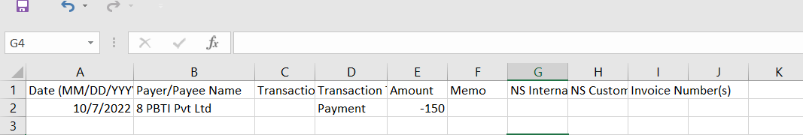
Step 2: Navigate: Transactions -> Bank -> Banking Import History -> Upload File.
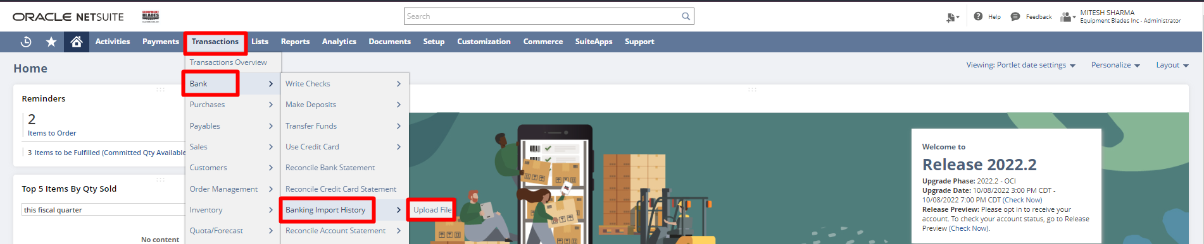
Step 3: To create the template in step 1, the file provided by Team Paapri can be used or download the Template by clicking on Download the CSV Template button. Once the file is created select the file by clicking on Choose a File. Select Import with a default parser radio button. Select the Bank Account for which the statement is being imported. Click Import. The status of the import can be checked by clicking on Banking Import History.
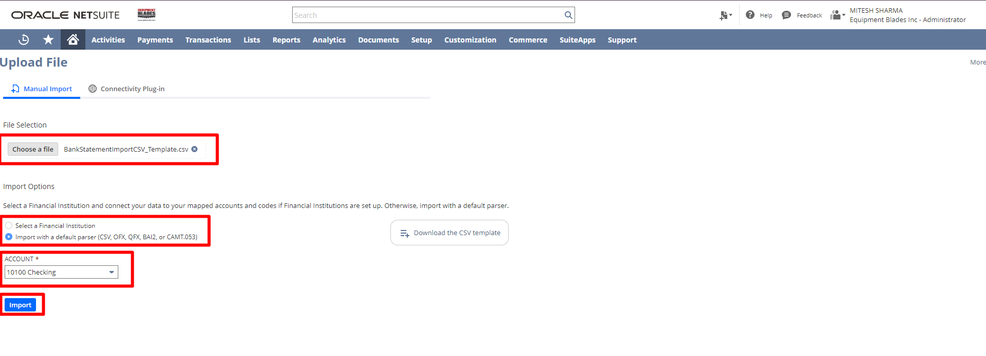
The Account Statement has been imported. Now the statement has to be reconciled. The account statement will be imported automatically if the bank accounts are linked to NetSuite via Bank Feeds.

Reconcile Bank Statement:
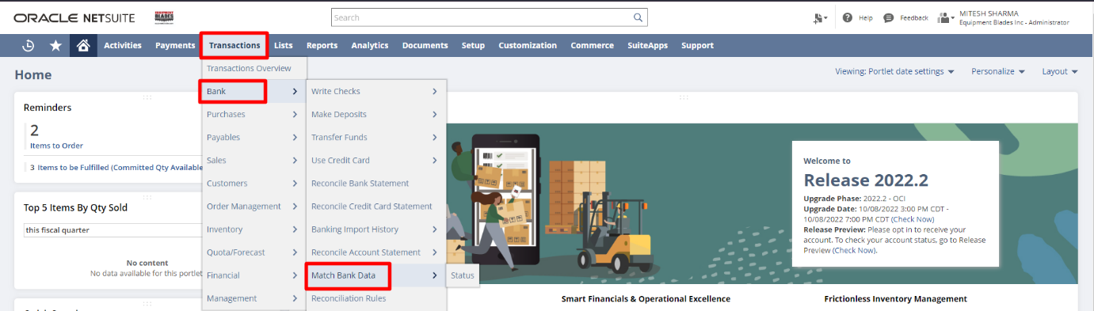
Step 1: Navigate Transactions -> Bank -> Match Bank Data.

Step 2: Select the Account which is to be reconciled. On the left side, we have bank transactions that we have imported using Banking Import. On the right side, we have the NetSuite Transactions for the selected account. Match the transactions on the left and right so the difference is 0. Click on Match.
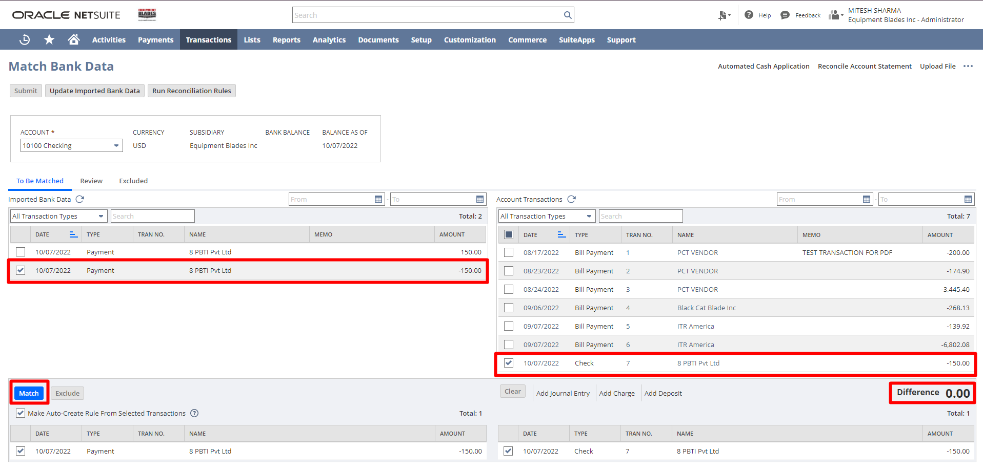

Step 3: Click Submit.
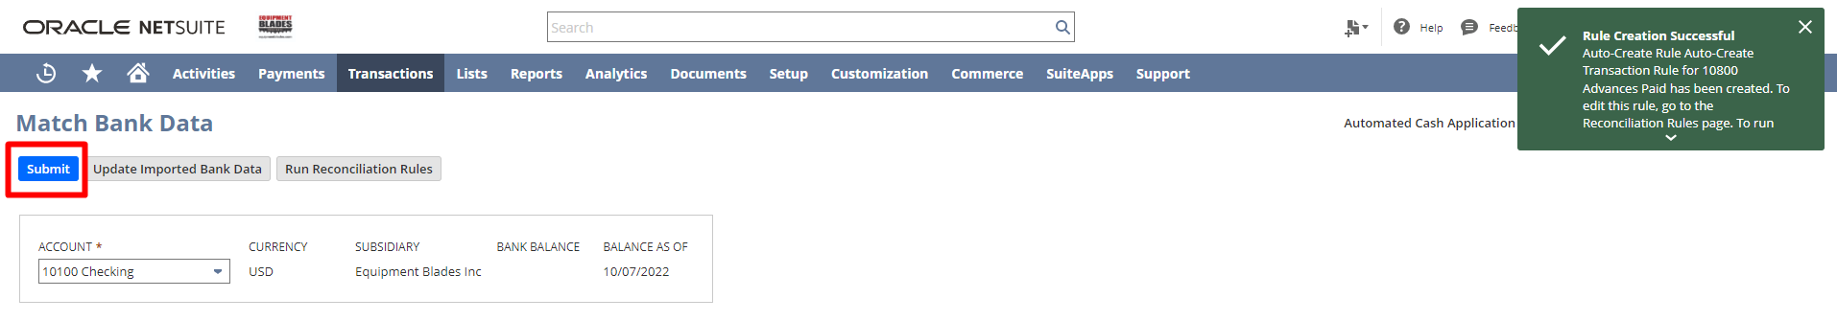

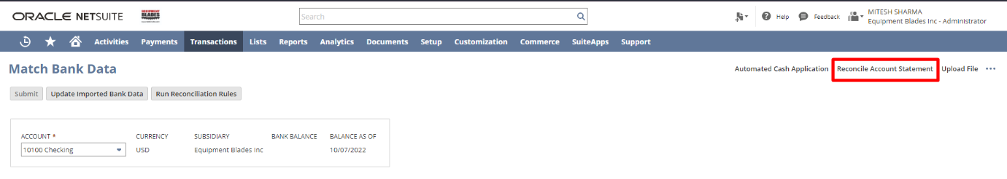
Step 4: Click Reconcile Account Statement.
Step 5: Enter the Ending Statement Balance. Check the checkbox for the transactions to reconcile and click on Reconcile.
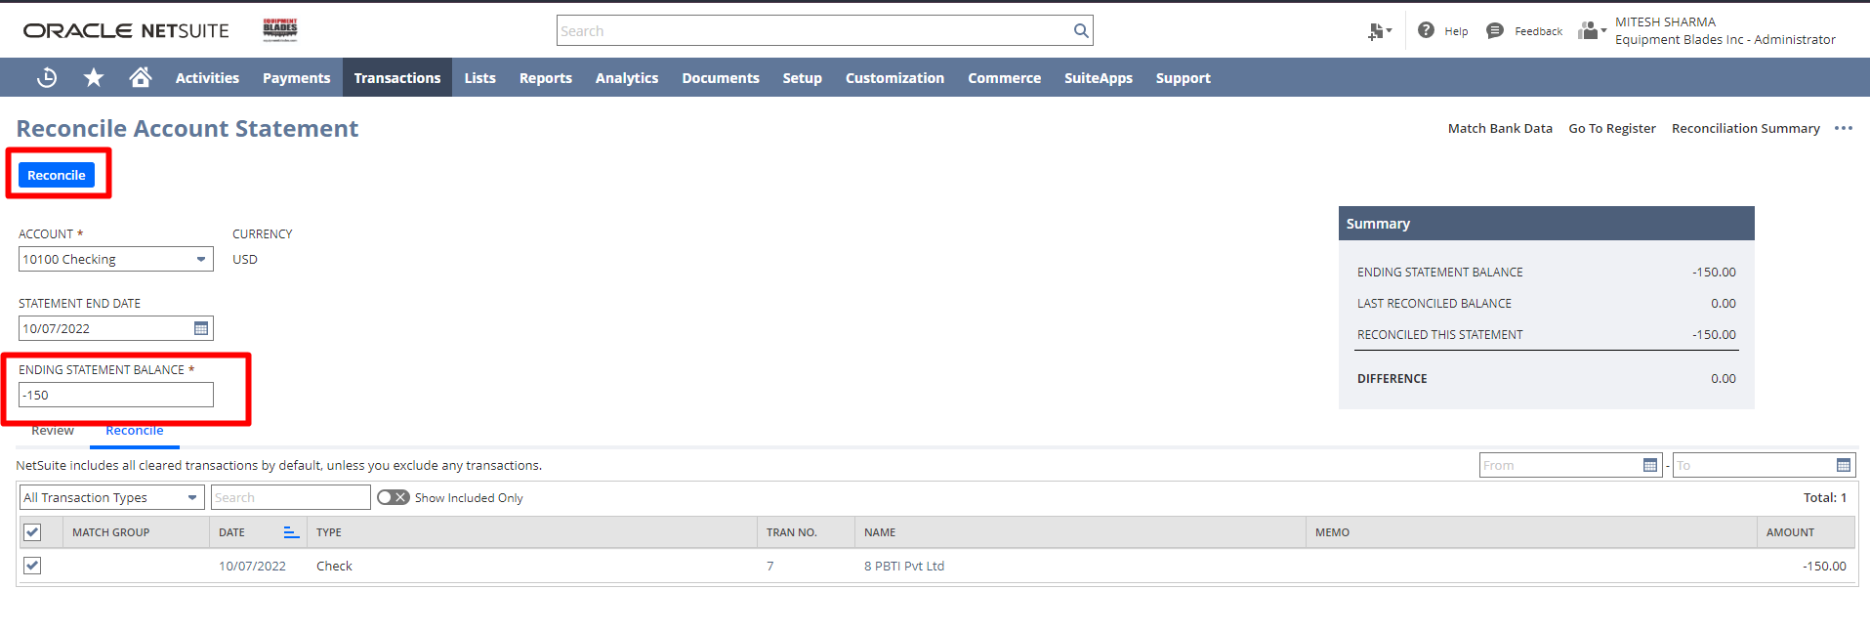

Signature: ________________________________
Date: _____________________________________

Disclaimer:
Upon signing off on the process flow document, you are confirming that the process has been set up per the SOW within NetSuite per your business's needs. Any changes or modifications requested after sign-off will need to be a "change request" at an additional fee.

*** PLEASE ensure that you have logged into NetSuite and tested the process prior to signing off on the setup. Paapri requires sign-off on this document prior to moving forward with any additional design meetings.

